Name: SANKALP VERMA

User Assignment – 1

Problem Statement: (Selecting Data)

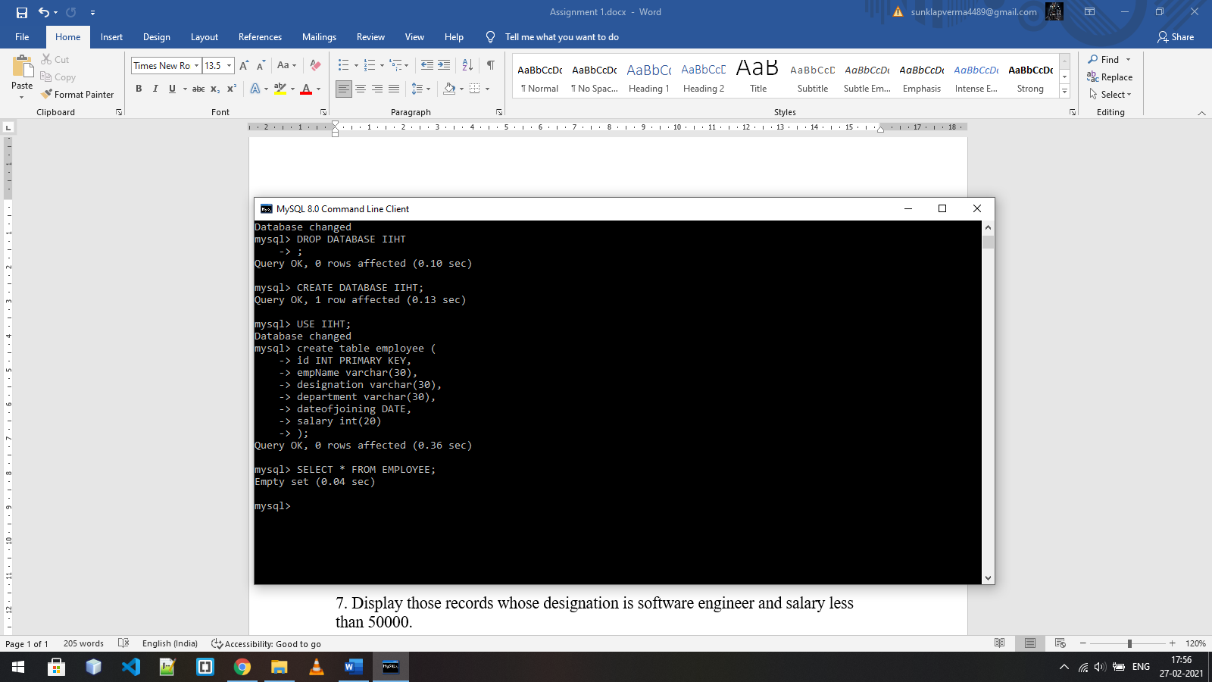1. Create a database called IIHT and a table called employee with columns id, empName, designation, department, dateof joining and salary with appropriate data types for the columns.

2. Insert at least 10 records to the table.

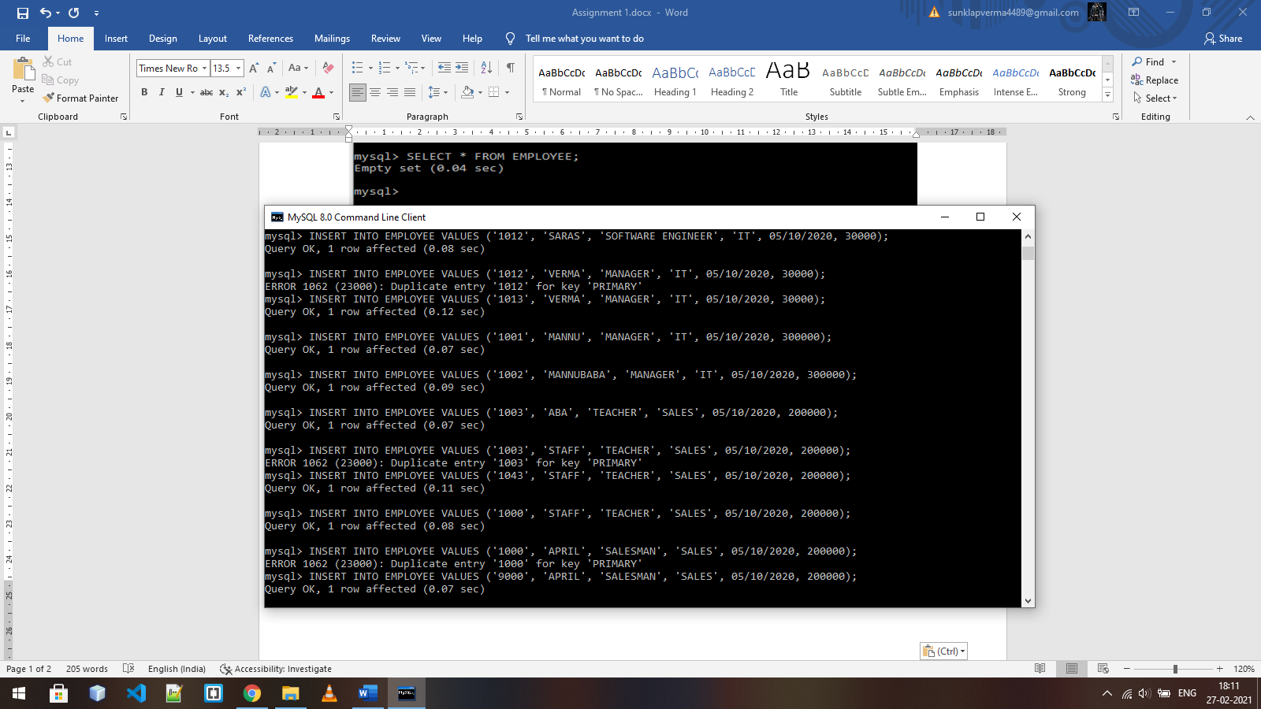

3. Display all the records on the console.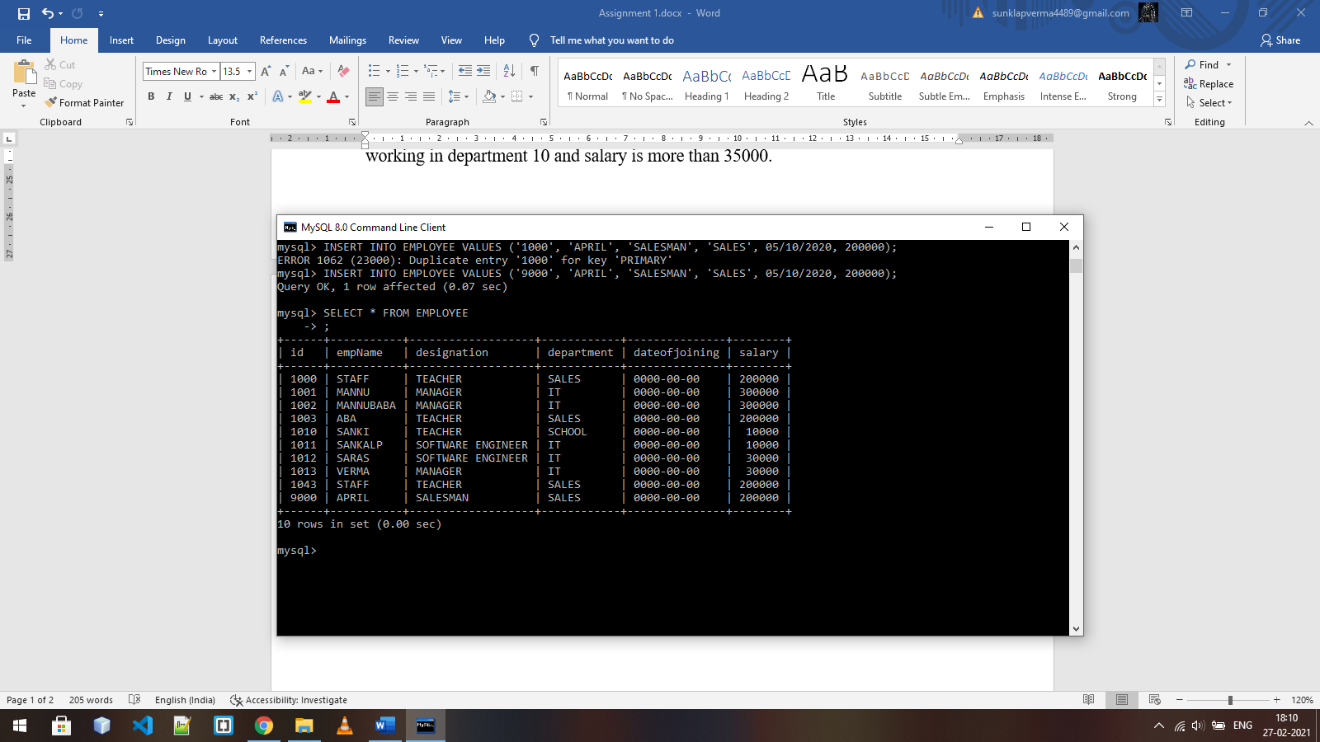

4. Display only id, empName and designation columns only.

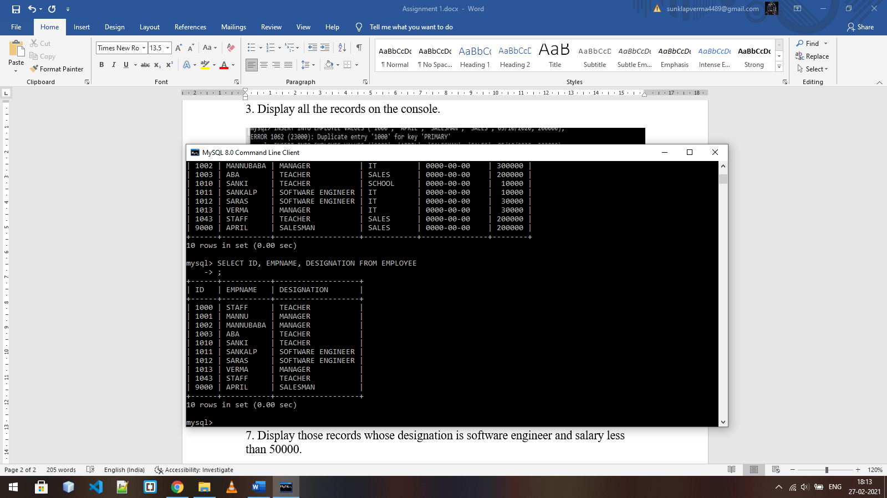

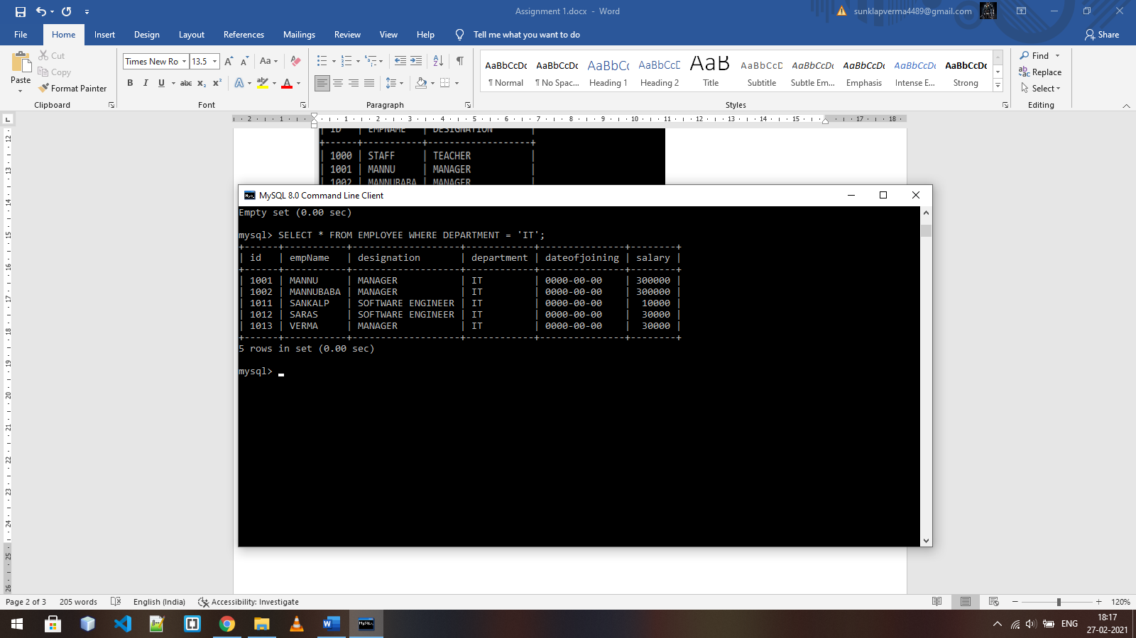5. Display those records who are working for a particular department.

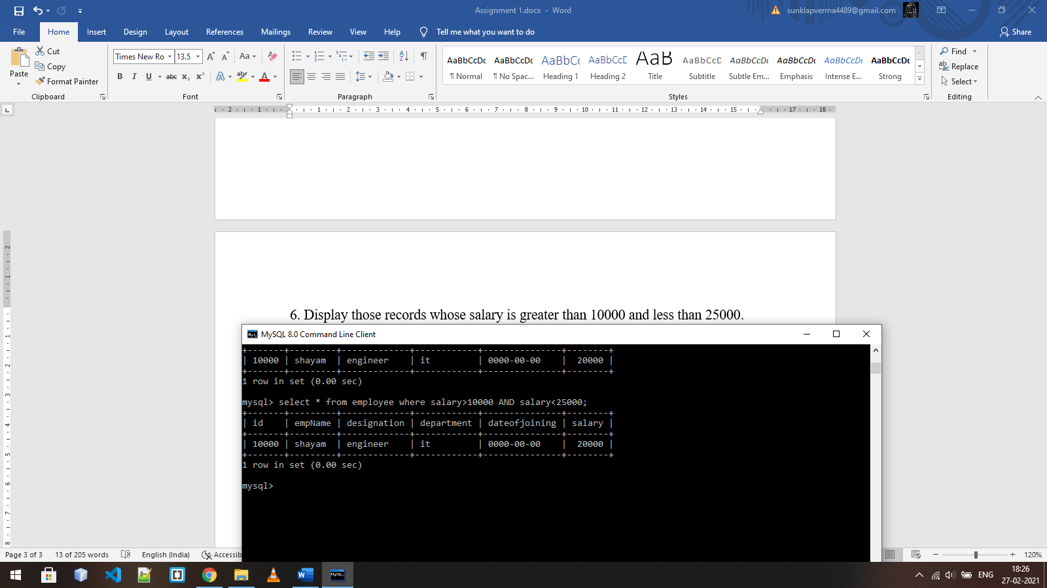6. Display those records whose salary is greater than 10000 and less than 25000.

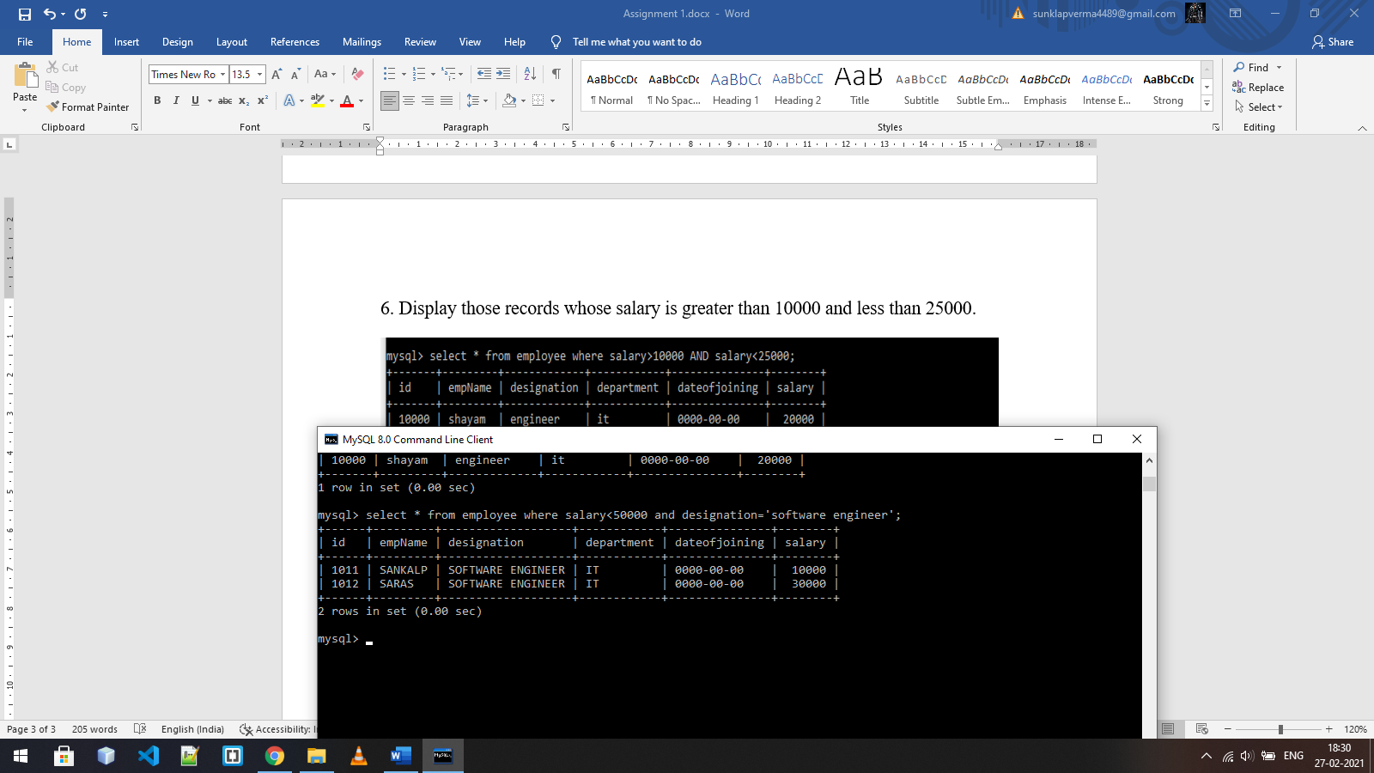  
7. Display those records whose designation is software engineer and salary less than 50000.

8. Display all the records whose empName start with ‘A’

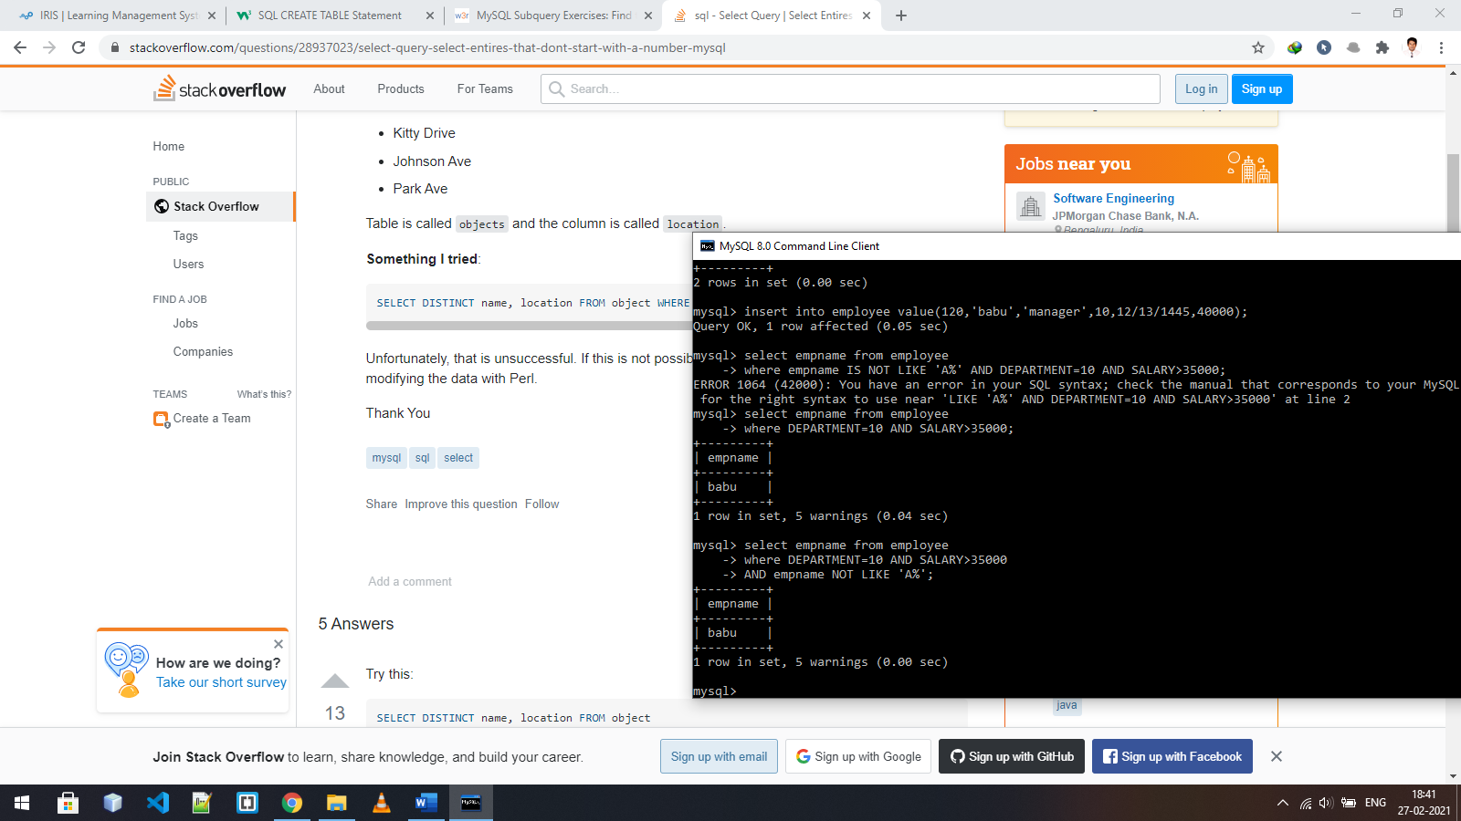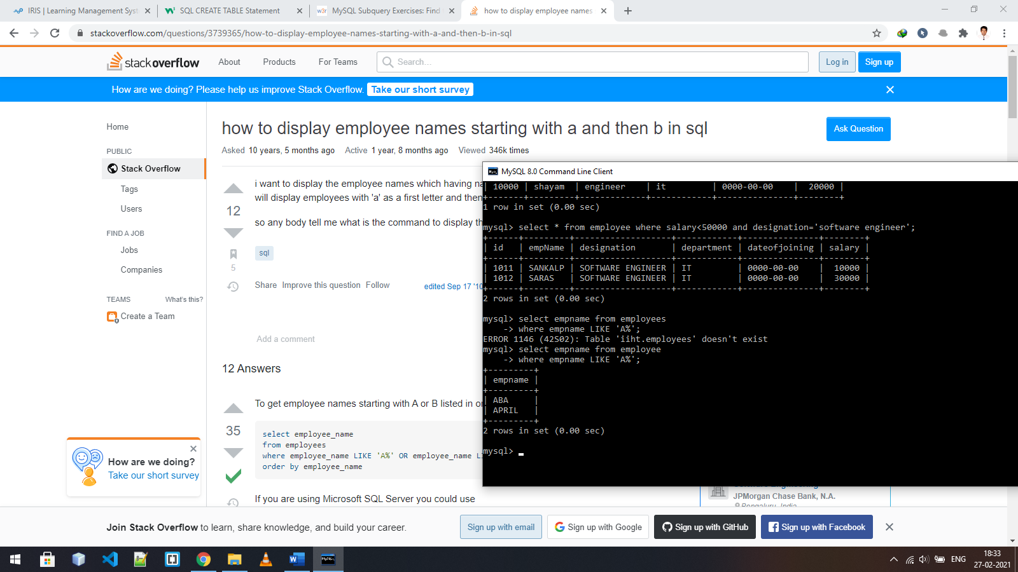  
9. Display all the records whose employee name is not starting with ‘R’ and working in department 10 and salary is more than 35000.

10. Display all the records in the ascending order of their empNames.

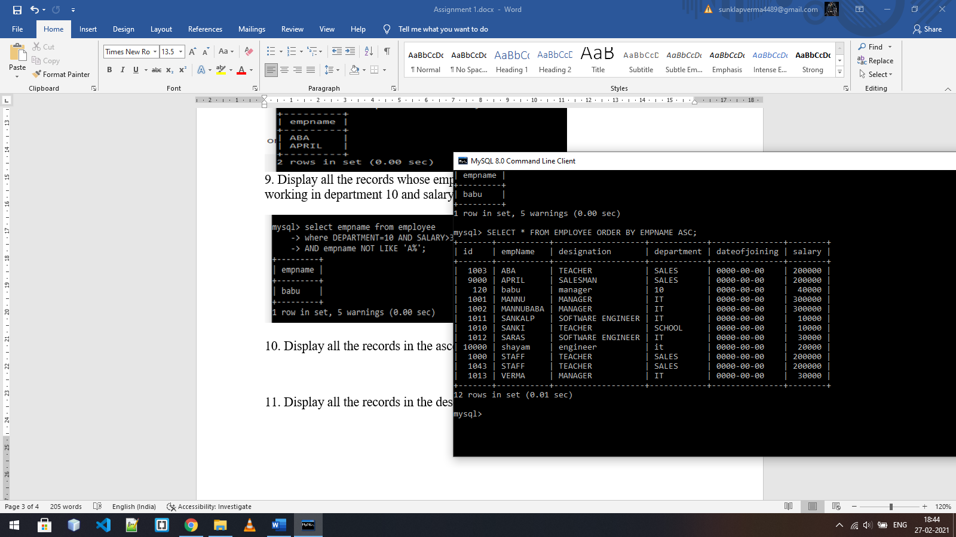

11. Display all the records in the descending order of their salaries.

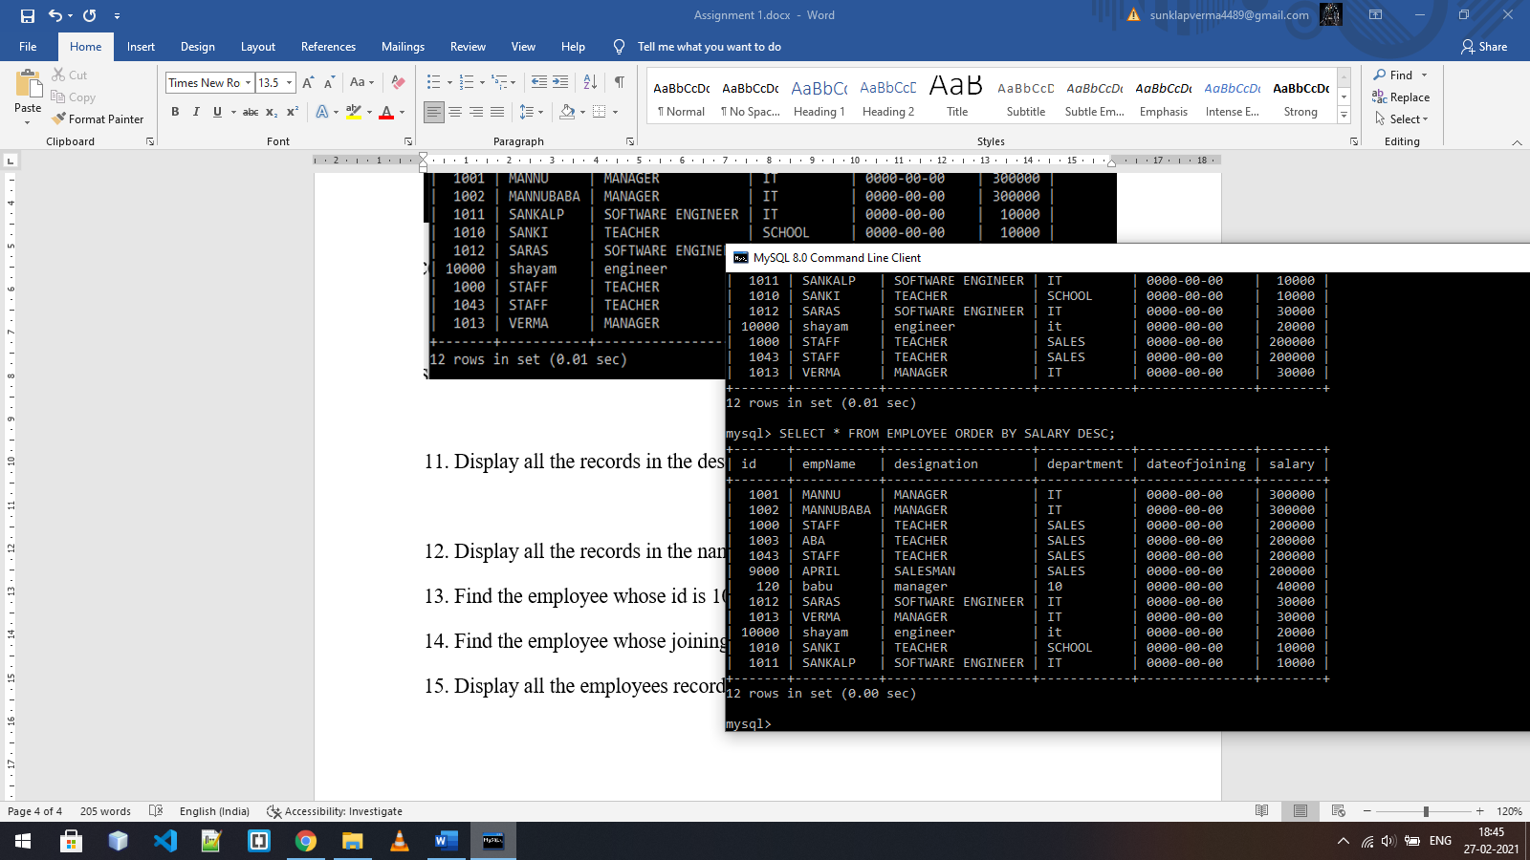

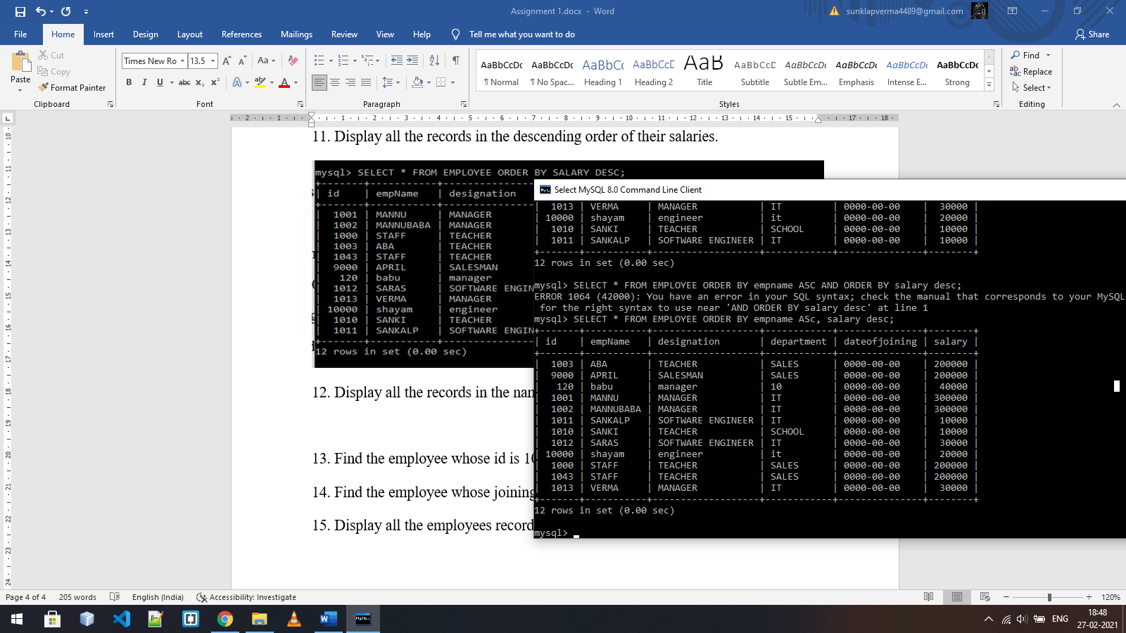12. Display all the records in the name ascending and salary descending order.

13. Find the employee whose id is 1001

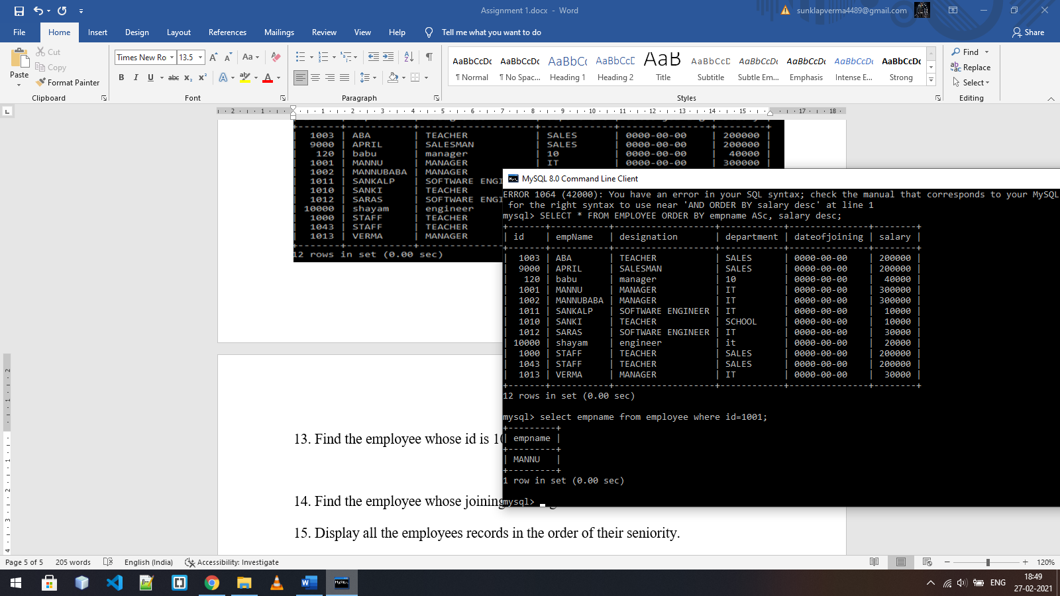

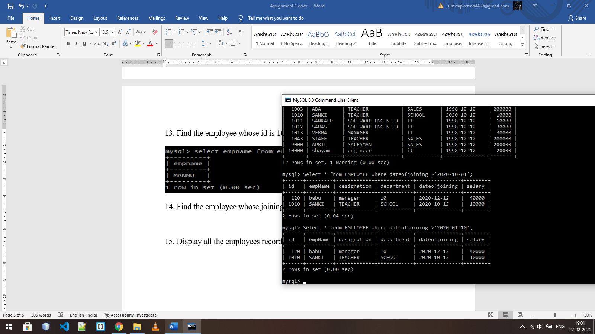14. Find the employee whose joining date is greater than ‘2020-01-10’

15. Display all the employees records in the order of their seniority.

Here we are using id number to check seniority. Senior members have low id number.

